YOUSUNG HOTEL

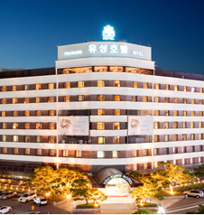 | Address: 9,Oncheon-ro,Yuseong-gu, Daejeon, 34169, Korea
Tel: +82-42-820-0617/0618
Fax: +82-42-822-0041
E-mail: kdh8158@naver.com
Website: http://www.yousunghotel.com/eng/index.do

A. Personal Information
□ Mr. □ Ms. □ Prof. □ Dr. □Other | GENDER □ M □ F
First Name: | Last Name:
Arrival (Check-In date): | Departure (Check-Out date):
Address:
City / Country: | E-mail:
Phone: | Passport Number:

B. Hotel Reservation
Room Type | □ Standard Double, □ Standard Twin
Room Rate (KRW) 95,000 (Spa free charge)
No. of Room
Special Request of Guest

* Breakfast (buffet) is served at 07:00 ~ 10:30 (additional KRW 12,000).
* All rates are included 10% service charge and 10% VAT.
* Check-in time 14:00 PM, Check-out time is 12:00 noon.

C. Hotel Reservation (Credit Card Information)
□ VISA □ MASTER □ JCB □ OTHER | Card Number:
Expiration Date(MM/YYYY): | Cardholder:
Remark: Your credit card information is for deposit for cancellation or no-show

▶ Cancellation Policy
- 100% Refund : 2 days before your check-in date
- No Refund : 1 days before your check-in date or No-show

Date : __________________________________ Signature :_______________________________

